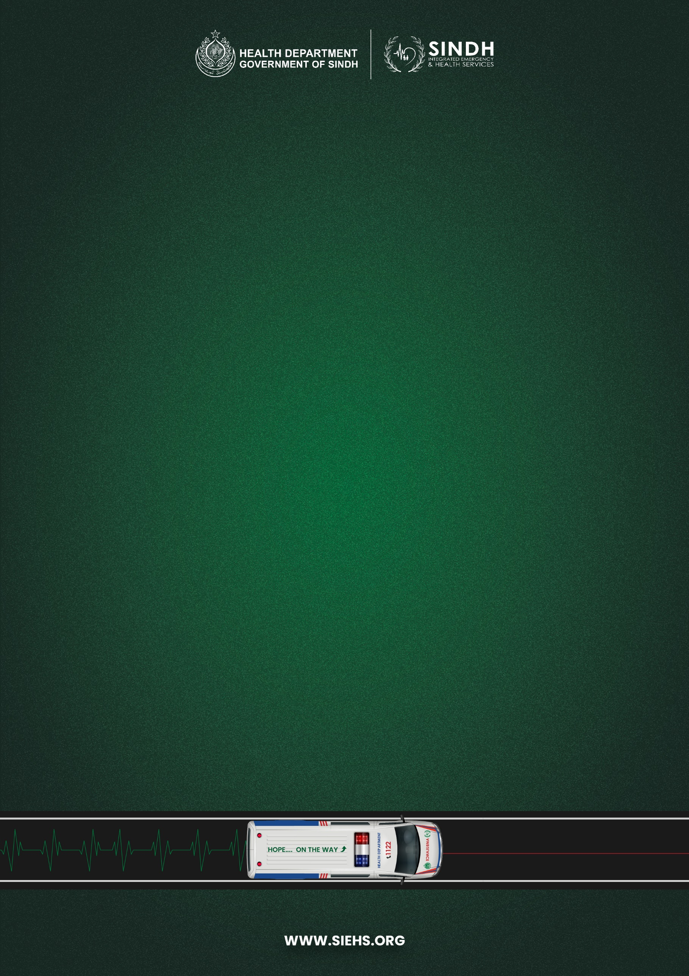

**STANDARD OPERATING PROCEDURE**

**KPIs OF FLEET DEPARTMENT**

|  |  |
| --- | --- |
| **Document no:** | SIEHS-FT-SOP-03 |
| **Issue no:** | 03 |
| **Issue Date:** | November 15, 2024 |
| **Pages:** | 03 |

|  |  |  |
| --- | --- | --- |
|  | **Prepared by** | **Reviewed &**  **Approved by** |
| **Name:** | Muhammad Abbas Nomi | Lt. Col. (R) Ali Akbar Jhandeer |
| **Designation:** | Manager Fleet | Head of Support Wing |
| **Signature:** |  |  |

**TABLE OF CONTENTS**

1.0 PURPOSE 1

2.0 SCOPE 1

3.0 RESPONSIBILITY 1

4.0 PROCEDURE 1

5.0 RELATED DOCUMENTS 2

6.0 REASON OF CHANGE 2

# 1.0 PURPOSE

**1.1** To have a written source of standards that provide a clear guide for the scope of SIEHS Fleet.

# **2.0 SCOPE**

**2.1** This procedure applies to SIEHS Fleet

|  |  |  |  |  |
| --- | --- | --- | --- | --- |
| **KPI** | **Benchmark** | **Data Source** | **Achieve Target** | **Frequency** |
| Ambulance on road according to the current fleet station, | **90%** | CCC / Operations |  | Daily, weekly, monthly |
| External Repair, paint and branding, hooter & lights etc. | **90%** | Fleet / Operations |  | Monthly through random assessment of 20 ambulances by the MEAL Department |
| Average visit per ambulance to the workshop per month *(Total ambulance called to the workshop / Total ambulance in the fleet)* | **<1** | Workshop |  | Monthly |
| Weekly reports on the number of accidents | **No Benchmark** | Fleet |  | Weekly |
| % Of warranty/insurance work costs recovered through claims | **100%** | Fleet / Finance |  | Monthly |
| Repeat jobs | **0%** | Fleet / CCC / Operations |  | Monthly |
| Preventive Maintenance compliance | **90%** | Fleet / Biomedical |  | Daily, weekly, monthly |
| % Of fleet staff & drivers with complete Training as requested by training and P&C | **90%** | P&C / Operation |  | Annually |

# 3.0 RESPONSIBILITY

**3.1** Head of Admin & Security, Fleet Team, all Operational and Bio-Medical of SIEHS will be responsible for fully complying, or ensuring full compliance, with every provision of this Standard.

# 4.0 PROCEDURE

**4.1** KPIs, Benchmark and frequency of reporting

**4.2 KPIs Monitoring:** Whole station Management is responsible for accountability of the Fleet Department’s performance as per decided Key Performance Indicators. Management has to appropriately maintain and update the KPIs from their accurate verified Data.

# 5.0 RELATED DOCUMENTS

**5.1** None

# 6.0 REASON OF CHANGE

**6.1** This is a new Document

6.2 Changes have been made in complete document.